On the Beat in

Cleobury and Highley
Safer Neighbourhood Team |  |  | August 2023
Where we work
The Safer Neighbourhood Team are based in Bridgnorth Police Station, Wenlock Road, Bridgnorth, Shropshire, WV16 5BB. However we also operate out of Highley Police Station and have an office at the Market Hall in Cleobury Mortimer. We also cover Ditton Priors, Stottesdon, Eardington, Chelmarsh, Middleton Scriven, Aston Botterill, Billingsley, Burford, Chetton, Farlow, Neen Savage, Sidbury and Middleton Baggot.
Team contact details
Team email: ch.snt@westmercia.pnn.police.uk
Safer Neighbourhood Officer | Police Community Support Officer
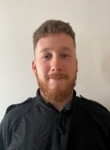 | 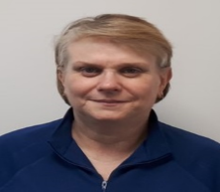
PC Oliver Jones | PCSO Jacqui Fletcher
New phone number to be obtained soon | 07816238536
Police Contact Details: Please remember we are not personally on duty 24 hours also on rest days and leave so leaving a message on our mobile phones will not necessarily give the fastest response.
Emergency: 999 |  | Website: www.westmercia.police.uk
NonEmergency: 101 https://www.westmercia.police.uk/ |  | Twitter: @Cleoburycops
Crime stoppers: 0800 555 111 or https://crimestoppers-uk.org/give-information/forms/give-information-anonymously
Sign up to Neighbourhood Matters … your brand new community messaging service
 |  | Neighbourhood Matters enables residents, businesses and Community groups to keep in touch with local policing teams. You can choose exactly what type of alert you wish to receive and how you receive them; whether that be by email, text or telephone. Sign up now at: www.neighbourhoodmatters.co.uk
Community Saftey  Anti-Social Behaviour.  In the Cleobury area we have had reports that a motorcycle was being ridden recklessly and with a modified exhaust, causing alarm and distress. Any information would be helpful.  In Highley there’s also a red scrambler bike riding around and also on footpaths, with no registration plate or helmet, he is also causing alarm and distress. Two addresses have been knocked and searched and sadly the bike was not there. SNT have one more name to check and will be contacting the roads policing unit at Telford for assistance with this if it continues.  By using social media we are hoping for witnesses to provide information for the rider to be identified. Once we find out the person we can send a letter out to them and if they continue to ride in the manner, their motorcycle will potentially be seized by the Police.  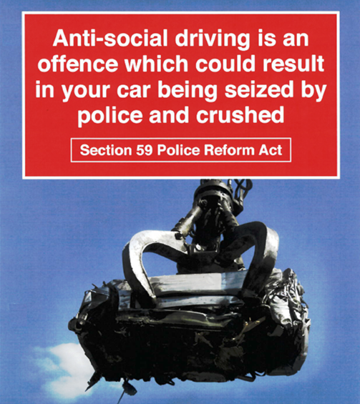 |  | Cleobury Mortimer and surrounding areas:  Speed Surveys.  Thoughout the month SNT Officers will be conducting Speed checks in Burford, Cleobury, Kinlet, Button Oak, Burwarton, Eardington, Chelmarsh, Billingsley and many other areas in the Cleobury and Highley area.  Engagement.  On the 1st July the new SNO - PC Oliver Jones attended Highley Carnival and he had a wonderful time and spoke to local residents. PC Jones and PCSO Fletcher also attended Chelmarsh fete on the 8th and had a coffee with local residents. SNT have also planned Police surgeries in Highley and Cleobury the first one will be 19th July 2023 at 16:00-18:00 hrs at Cleobury Market Hall office, the next one will be 20th July 2023 at 16:00-18:00 hrs at Highley Police Station, Severn Centre, the ones for this month are 21st August 2023 in Cleobury at 16:00-18:00 and the one in Highley the 27th August 2023 at 14:00-16:00 this will be Tweeted and put on Neighbourhood Matters in the near future.  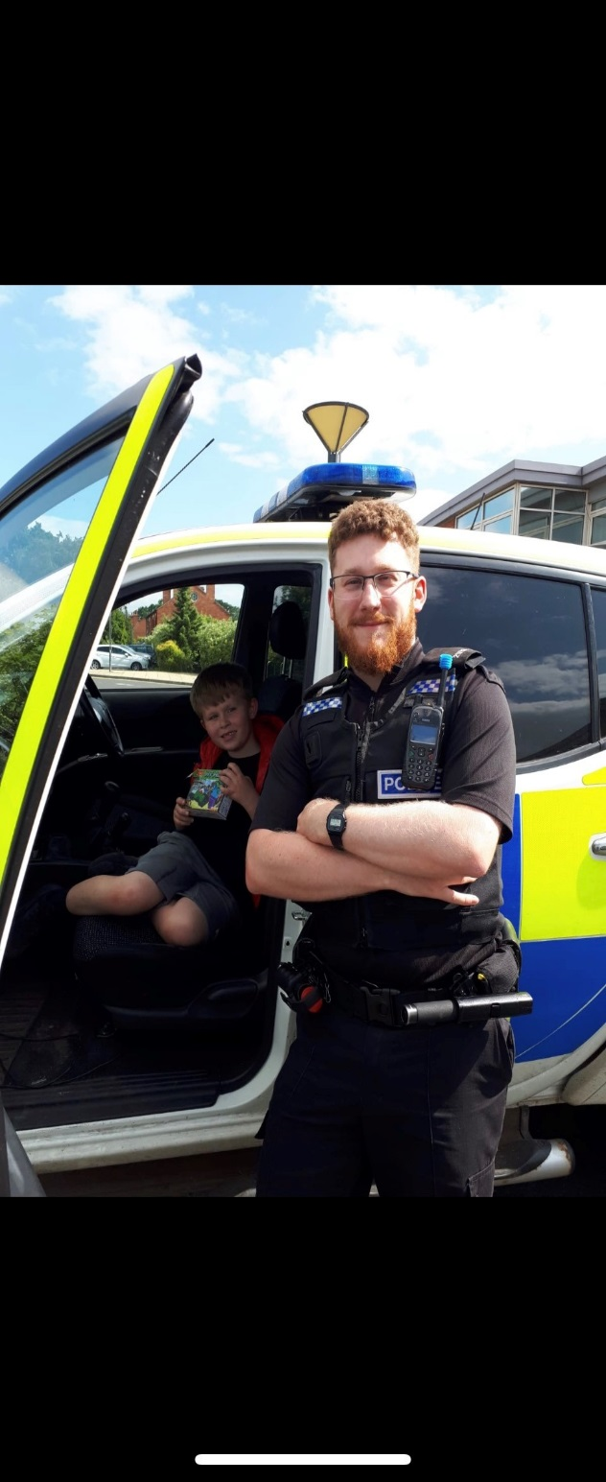
PC 21783 Oliver Jones  In my first month on the new role I have began to start an intelligence system with residents to try and tackle drug use and supply in the area and have began to understand the persons involved in this. I will soon begin looking at solutions to tackle this but do require more information from residents affected by this force priority.  I have visited the local care homes in the area and also met vulnerable people who we have on plans to ensure safeguarding and any assistance we can provide is given.  I have assisted response with domestic incidents while still knocking on doors in the Highley area to try and improve the parking situation – focusing on Clee View which is a concern for local people. I have also provided a link to report this on our team twitter page.  I have dealt with a neighbour dispute and provided a warning to one member of the community to try and resolve any further incidents. I have spent time trying to locate the red scrambler bike in the Highley area while also attending local events and meeting children in the area to try and improve relations with the police.  I have also viewed CCTV for two separate incidents in Highley and Cleobury which assisted investigations into criminal damage and an assault. |  | Warrant – S32 Misuse of Drugs Cleobury Mortimer  This was my first warrant in the role and was served on Tuesday 17th July 2023. I had the assistance of our specialised teams such as the LPPT, NCFT and Bridgnorth, Shifnal, Broseley & Much Wenlock SNT. This is the beginning of what I hope to be more operations planned to tackle drug supply and use which has wider implications on the area.  Take Five To Stop Fraud  STOP: Taking a moment to stop and think before parting with your money or information could keep you safe.  CHALLENGE: Could it be fake? It’s OK to reject, refuse or ignore any requests. Only criminals will try to rush or panic you.  PROTECT: Contact your bank immediately if you think you’ve fallen for a scam and report it to Action Fraud  ALWAYS REMEMBER:  · Avoid disclosing security details  · Emails, Phone Calls and Texts may not be authentic  · Always make direct contact with any organisation by using a genuine phone number  · Stop and Challenge any unexpected requests  · Protect others by reporting Fraud and Scams

