Chorley Village Hall Tea and Cake afternoon

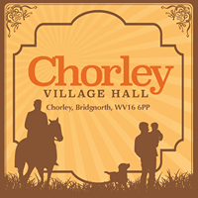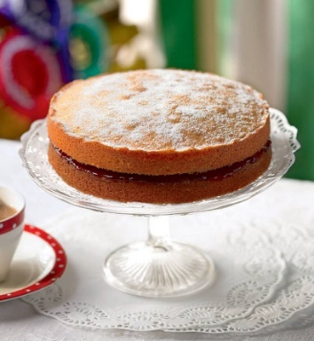

Thursday 12th March 2020 at 2.00pm
Join us at Chorley Village Hall for a cuppa, a cake & a chat.

For more details phone Claire on 01746 718022 or email: Claire@woulfe.org.uk

Chorley Village Hall Tea and Cake afternoon

Thursday 12th March 2020 at 2.00pm
Join us at Chorley Village Hall for a cuppa, a cake & a chat.

For more details phone Claire on 01746 718022 or email: Claire@woulfe.org.uk

